**Oracle Cloud Infrastructure (OCI)**

Oracle Cloud Infrastructure and Oracle Cloud Application are the Cloud offerings by Oracle.

Oracle Cloud Infrastructure also referred to as Platform as a Service (PasS).

1. Compute
2. Storage.
3. Networking.
4. Database – Oracle and Open Source (like HeatWave SQL and PostgreSQL).
5. Analytics & AI.
6. Developer Services (like Kubernates Cluster (OKE)).

Oracle Cloud Application is also referred as Software as a Service (SaaS).

1. Enterprise Resource Planning.
2. Supply Chain Management.
3. Human Capital Management.
4. Advertising and Customer Experience.

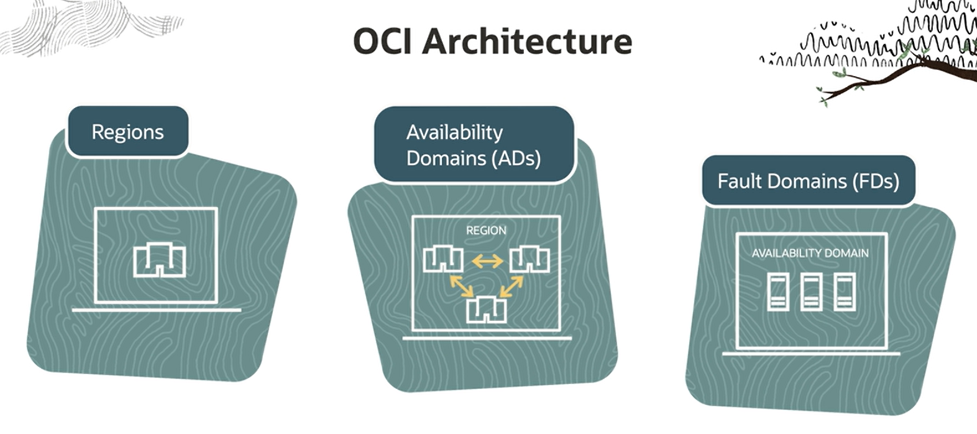

Choose a **Region** that could be a Geographic location closest to the user base or a Country that has strict data residency requirements. Example Europe or America are examples of region.

**Availability Domains** are basically one or more Data Centers located in a Region. The physical Infrastructure are not shared.

**Fault Domains** are a grouping of hardware and infrastructure within an Availability Domain. Each Availability Domain has 3 fault domain.

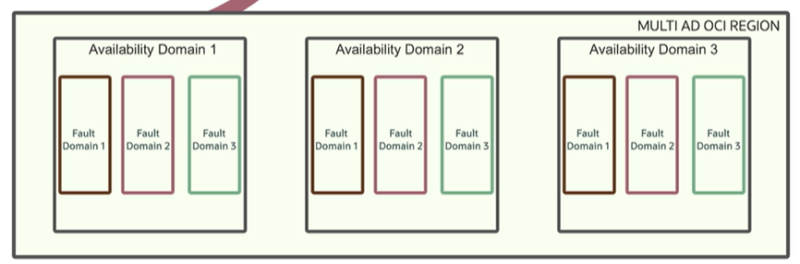

Type of Compute

1. Virtual Machine (VMs) – Multiple VMs can run on a single Physical Hardware. Physical Hardware is shared by multiple entities or organizations which the users don’t know.
2. Bare Metal – Dedicated Physical Hardware.
3. Dedicated VMs – Run Virtual Machine on dedicated Physical Hardware. Here Physical Hardware is set up to run VMs for your organization only.

Virtual Machine (VMs) can have Fixed or Flexible shapes. That is the option to choose the number of CPUs and amount of RAM.

VMs can be Vertical Scaled or Auto Scaled.

Vertical Scaling – User can choose the number of CPUs and amount of RAM. There will be brief downtime as well.

Auto Scaling – Set a Performance metric and threshold for that metric. Autoscaling event will be triggered if the threshold is met. Or schedule the Auto Scaling based on weekdays or weekends.

Type of Storage

1. Block Volume – Storage for Compute instance just like Hard Disc for Laptop. Attach/Detach the Block Volume with a compute instance in case of creation/deletion.
2. File Storage – Network drive or NAS storage to store files.
3. Object Storage – Storage on the web to store any file format like images, videos etc.

Objects are stored in buckets which is like a folder that can store the object under StorageTier like Standard, Archive, InfrequentAccess.

Virtual Cloud Networks (VNC)

IP Addresss are numbers attached to a resource to uniquely identify and locate it. Just like our home address to uniquely identify.

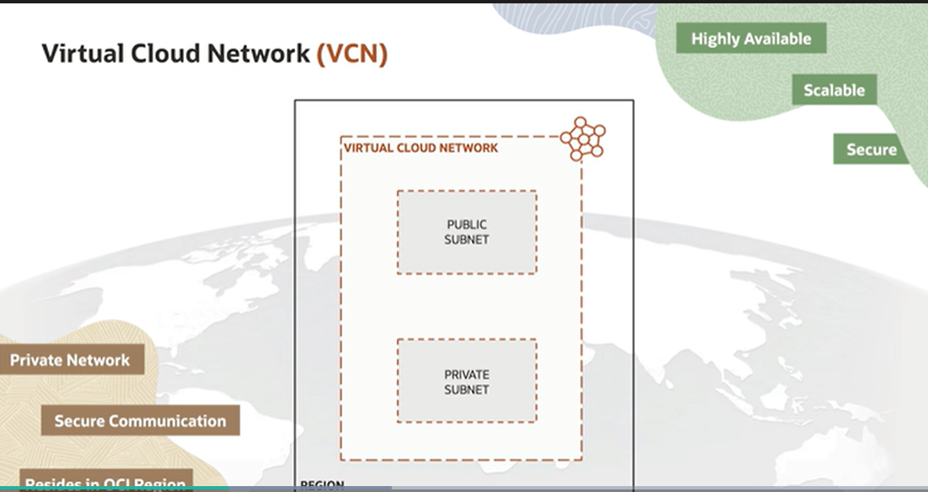

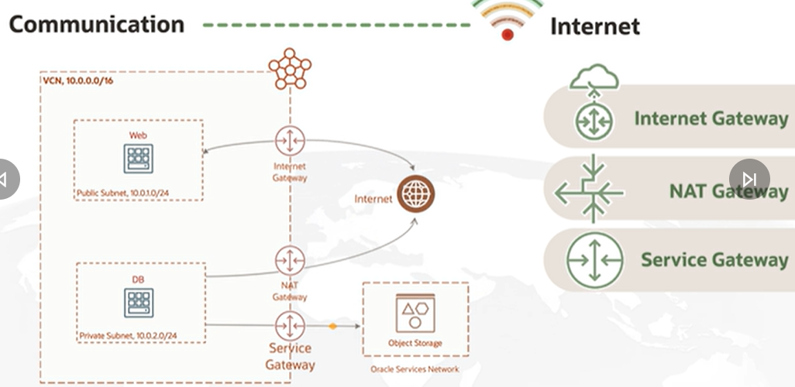 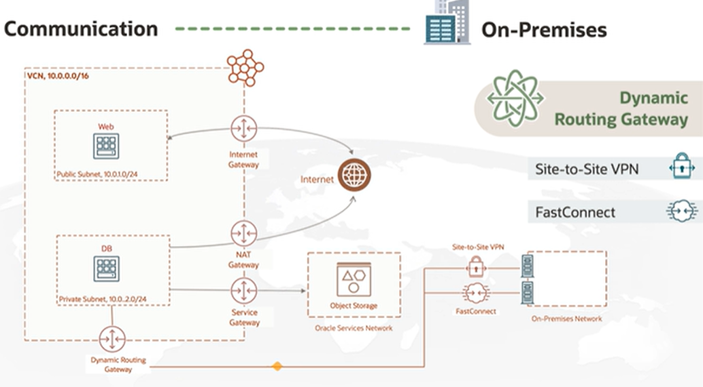

Security Services by OCI

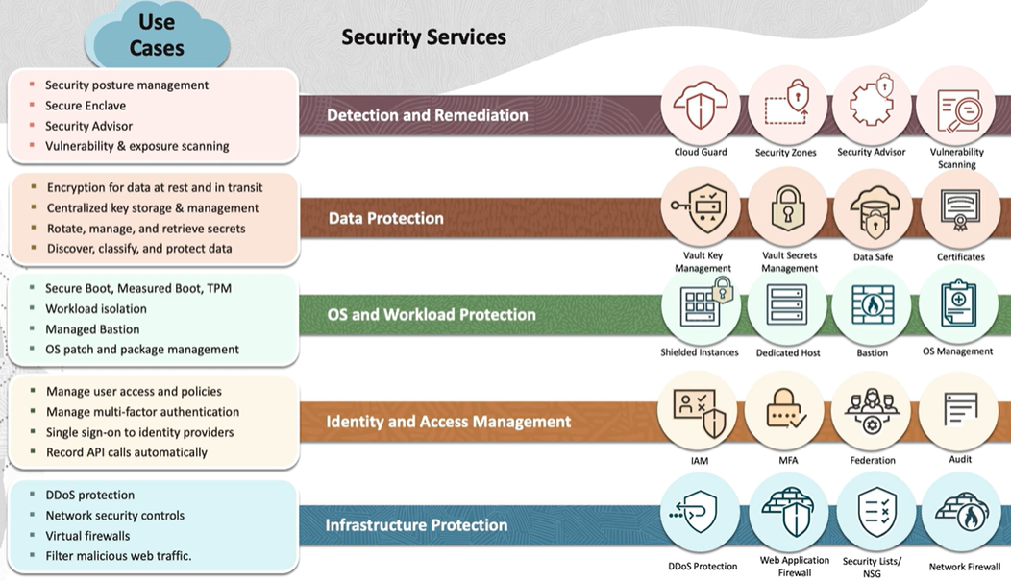

Cloud Native App – Applications that were designed to reside on the Cloud from the very start.

**Containers** are Software Packages that perform well defined tasks.

**Microservices** approach software development where software is composed of independent services that communicate over well-defined APIs.

**Declarative APIs** are a desired state system.

**Immutable Infrastructure** approach is to manage services and software deployments on IT resources where components are replaced rather than changed. So, whenever any change occurs the application or service is effectively redeployed.

**Service Meshes** is a way to control how different parts of an application share data with one another.

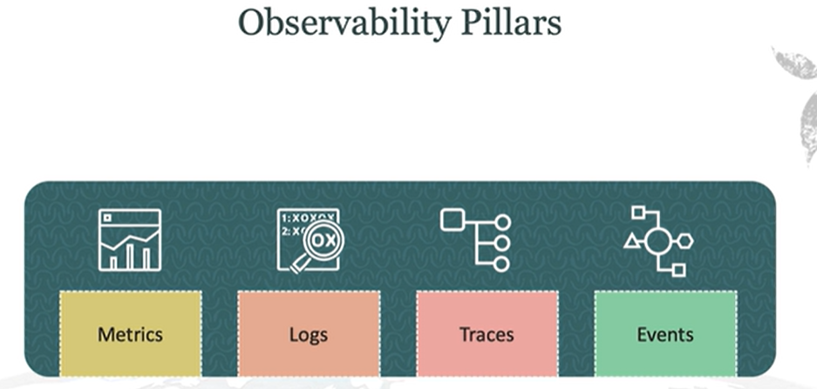

Multi Cloud - OCI Azure Interconnect has created highly optimized, secure and low latency unified cross cloud experience.

Hybrid Cloud

**Oracle Cloud Application (OCA)**

Oracle Cloud Application also referred to as Software as a Service (SasS).

